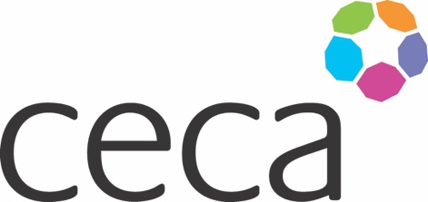

Midlands ANNUAL DINNER 2025

CECA MIDLANDS AWARDS

APPLICATION FORM

INNOVATION AWARD 2025 in memory of Keith Baldwin

Keith Baldwin was the founder of HTM, a supporter of CECA Midlands but also a great innovator, spearheading good practice and new ideas to increase productivity and efficiencies. Our Innovation Award recognises advancements in the industry that demonstrates creativity, technological progress and efficiency. This award

is aimed at recognising teams and/or organisations who embrace innovative ideas to deliver improvements in their work practices whilst still keeping to (or improving) budget projections and gaining client satisfaction.

This category is open to CECA Midlands member’s and may be based on a project in the Midlands or a companywide initiative which impacts projects within the region.

The Awards celebrate the best innovative outcomes delivered against the project/ organisational goals and the entries should reflect that.  The entry should have one main proposer but feel free to provide details of other relevant parties such as the client, principal and, or specialist contractors and your main team. (With written permission if you are providing details).

**Criteria**

Each written application should be accompanied by at least one photograph of the completed project/Innovation and may be supported by up to three different photographs of the project under construction along with client endorsement if appropriate. (Maximum of 1200 words).

The submission must endeavour to meet the following criteria – ideally incorporate these criteria as headings or make them easy to identify:

* Successful introduction of Innovative – what problem did the innovation solve
* Risk Mitigation – how did the innovation mitigate, manage or minimize risk (e.g. Financial, safety, environmental, technological)
* Collaboration – what collaborative approaches did you undertake to improve the project/organisational outcomes, how did you foster a culture of adoption and continuous improvement
* Industry/community impact- - how has the innovations advanced the industry/your work or benefitted the community
* Any other stand-out performance that particularly merits this award

**Award**

The Award will be recognised by an engraved trophy and certificate presented at the Annual Dinner on 11 September 2025. Judging will be undertaken by unassociated industry representatives.

**Closing date**

All submissions must be emailed to [office@cecamidlands.co.uk](mailto:office@cecamidlands.co.uk) to **arrive by 5pm, 13 June 2025.**



Midlands ANNUAL DINNER 2025

**NOMINATING COMPANY DETAILS**

|  |  |
| --- | --- |
| Company name: |  |
| Contact name: (author) |  |
| Contact job title: |  |
| Contact telephone: |  |
| Contact email: |  |

**SUBMISSION (below)**