**Project**

As a team you will need to pitch for a contract that will provide infrastructure support for a local town. The town is in a semi-rural location and has a very active population who want to ensure the local community has easy access to the train station and can reach the town centre quickly and safely via this bridge. The bridge would span 95metres over the river and provide pedestrian access to and from the town centre. There is already vehicle access to the train station via an existing road route into town. This build needs to be environmentally friendly, thinking of creative ways to re-use and recycle materials, source local products and consider the sustainability of the build.

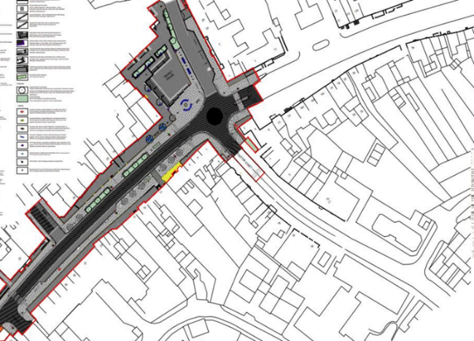

**Project Details**

Build a new, state of the art bridge.

* Improve pedestrian access to and from the town centre to the train station.
* Could there be a cycle path, as well as pedestrian access.
* Clear wide footpaths to increase pedestrian access. Clearer marked cycle paths if appropriate.
* Possibly create extra parking at train station.
* Planting trees and shrubs to create attractive areas. Increase lighting across the bridge.
* Create a structure that is eco-friendly and attractive so that people feel pride in their local area and are more likely to visit, eat and shop here.

**Project 1 - Job roles**

**Project manager** - I lead the team, ensuring that works are delivered to on time and within budget. I also manage the relationship with our client Project Managers (this means working together with other companies). I ensure that the site is safe, and staff are operating machinery correctly.

**Construction Buyer** – I consider the most appropriate materials and buy them. I focus on ensuring the materials are sourced and delivered on time for each stage of the project.

**Design and planning officer** – I manage the design and planning stage of project. Exploring suitable design possibilities and appropriate materials. I present these design ideas and make my suggestions about the most appropriate design.

**Social Values Co-ordinator** – I think about the impact on the wider community and environment. I organise and get involved in local projects to not only highlight the work that is being done but to provide support and invest in the local community.

**Decide on the different roles within your team. Remember you will all need to communicate and work together to bring the project together.**

**Project Manager …………………………………………………….**

**Construction Buyer………………………………………………….**

**Design and planning officer ………………………………………………**

**Social Values Co-ordinator ……………………………………………..**

**Project 2**

**Choose your Bridge. Read the descriptions below and consider the advantages and disadvantages of each construction. As a team, decide on the**

**Bridge 1** - **An Arch Bridge** (CLM)

The Arch bridge works by transferring the weight across the bridge. The main supporting elements are arches. These bridges can be made from a range of different materials, and they typically require less material than a beam bridge with the same span. More modern arches are often made from steel, concrete or laminated timber. They are highly rigid and lighter in weight than some other bridges. The advantage of these type of bridges are that there are multiple design options, they are more economical than other designs and they can span a wide range of distances. The disadvantages are that they require an experienced designer as the arch must be perfect for the bridge design, they are also time consuming to construct and maintain.

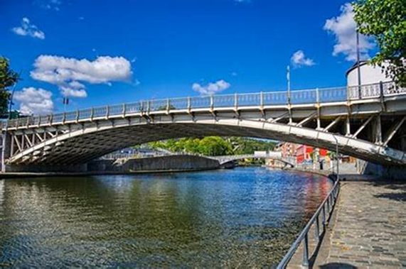

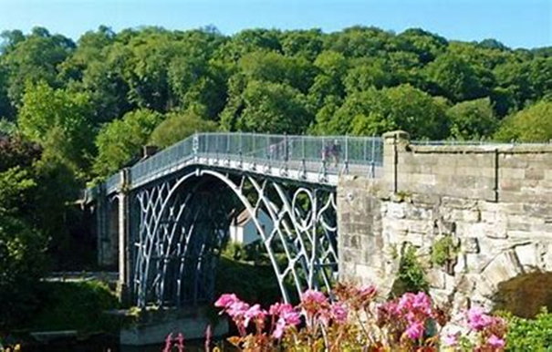

**Bridge 2** – **A Suspension Bridge** (Winvic)

.

The Suspension bridge is where the deck of the bridge is hung below the suspension. It is often used to carry road or rail traffic over a greater distance; however, they can’t hold as much weight as other bridge designs. Some advantages are that these bridges often look impressive, and they are relatively cheap to construct. However, a disadvantage is that they require significant foundation work which can be time consuming. They are commonly made from steel or reinforced concrete.

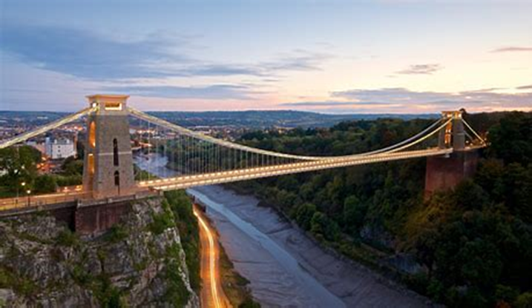

**Bridge 3 – A Beam Bridge**

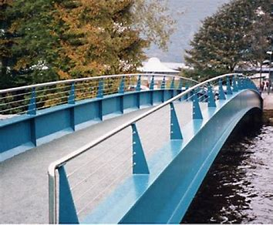

A Beam bridge is the simplest structural forms. The beam itself must be strong so it doesn’t bend under its own weight. These are often shorter bridges, but can be made longer by connecting smaller pieces together. Beam bridges are often made from timber, steel and reinforced concrete. Concrete is often the most cost-effective material to use. Some advantages of these bridges are that they are relatively cheap to produce and have low maintenance requirements. Some disadvantages of this type of bridge are that they can be very expensive if they are used for longer distances, they have a limited span length and can start to sag as they age.

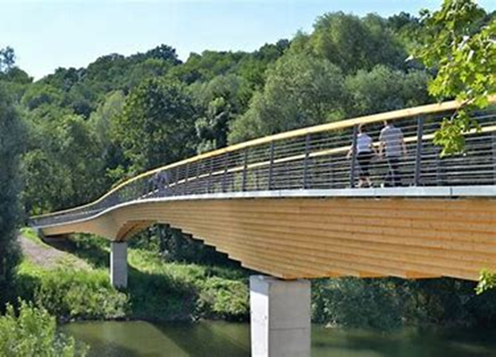

**Bridge 4 – A Truss Bridge**

A Truss bridge has a load bearing superstructure. The structure has connected elements, usually forming triangular shapes. A truss bridge is often one of the strongest bridges. The obvious advantages of this type of bridge are its strength and longevity. They are also very cost effective to make. However, they are extremely heavy and have high maintenance costs. They also require a lot of space as there are specific width requirements based on span length to achieve the required strength.

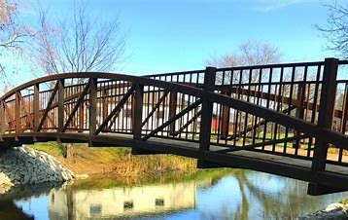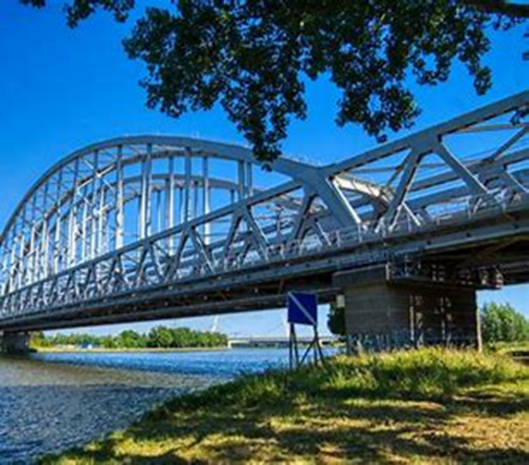

**Project 2**

**Our chosen bridge is:**

**Draw and label your bridge below**

|  |
| --- |
|  |

**Project 3**

**As a team work together to discuss the most appropriate material to build your bridge from. Explore the best design and consider the environmental opportunities that would ensure this project will be supporting the local community and preserving natural habitats of local wildlife.**

|  |  |  |
| --- | --- | --- |
| **Materials (Construction Buyer)** | **Design consideration (Design and planning officer)** | **Environment / Sustainability (Social values Co-ordinator)** |
| **CO2 friendly concrete**  Concrete has a great performance and can last a long time. Concrete is versatile which means that designers can still create beautiful bridges that fit perfectly with all different environments. | **Choice 1**  Pedestrian bridge, with extra wide paths for pedestrians Wheelchair access at train station and town centre.  Lighting will be at either end of the bridge to provide good lighting for entrance and exit.  Solar lighting will be fitted along the bridge.  10 additional car park spaces at the train station. | **Choice 1**  Plant some mature trees to provide animal habitats (bat boxes, bird boxes etc)  Take on local labour – giving local people jobs  Use local companies to complete different parts of the job |
| **Reinforced Steel**  Steel is perfect for carrying heavier loads. It is the strongest material (can be 10 times stronger than concrete) but it can be a little more expensive. Steel has lots of flexibility with its design and looks beautiful. Ensuring a good quality steel would be a vital consideration. | **Choice 2**  Pedestrian bridge with paths clearly marked for pedestrians.  Two-way cycle paths clearly marked. Appropriate place to securely leave your bike.  Lighting along the cycle path  Lighting along the pedestrian walkway.  Pavement art along the paths to create an attractive environment for commuters  20 additional car park spaces at the train station | **Choice 2**  Plant new trees and shrubs  Electric charging points at the train station for cars.  Electric bike hire.  Sourcing local materials to cut down on delivery costs and environmental impact of transporting materials.  Recycle rainwater to use on site. |
| **Timber**  Timber refers to wood that is specifically processed and prepared for structural applications – such as bridge building. Timber has been used for a long time due to its natural strength, durability and availability. It is often preferred for smaller bridges, pedestrian bridges, or those in rural areas. Timber is the most environmentally friendly material. | **Choice 3**  Pedestrian bridge with ramp access from the train station and town centre.  Two-way cycle path that is clearly marked.  Lighting along the whole bridge.  Bespoke railings to provide an elegant and attractive bridge.  15 additional car park spaces at the train station. | **Choice 3**  Plant new trees and shrubs  Re-wilding of local fields to create opportunities for local nature to thrive  Electric charging points for cars at train station |

**Project 4**

**Our Pitch – The bridge, chosen materials and design considerations**

**Our Pitch - The environmental considerations**

**Our Pitch – Identified risks and disruptions**

**Our Pitch – Identified public realm responsibilities (this is a responsibility that a company has to give back to the community during a project, some ideas are provided if needed)**



**Our Pitch – Why choose us**



**Further Information**

*This additional information could be provided to 16–19-year-olds so they can discuss and consider the additional factors (risk and disruption, material options, environmental factors and public realm responsibilities.*

|  |  |  |  |
| --- | --- | --- | --- |
| **Public Realm responsibilities -** *These ideas are ways to support your local community – your social values roles would consider these* | **Materials** | **Risks and Disruption** | **Environmental Factors** |
| Protect natural habitats | Concrete is commonly used for many bridges | Environmental hazards and pollutions | Use local labour and local workforce where possible. Create local jobs. |
| New lighting around bus shelters | Reinforced Steel is commonly used in bridge structure | Road closures and diversions around the town | Recycling of materials – what could be re-used on sight |
| New planting, including some mature trees | Stone can be used in for substructure | Signs will be implemented to show alternative parking in the town whilst the project takes place | Local sourcing of materials to reduce carbon footprint |
| Preserve local wildlife by creating wildlife corridors, putting up bird boxes in the local area and the re-wilding of a local field to encourage nature and wildlife | Composite materials – these have gained significant popularity | Alternative pedestrian access to the train station will need to be provided whilst the project is being completed. | Re-newable energy |
| Bespoke railings and pavement art  Improve market square so it can accommodate more traders and events | Aluminium – vary in how strong they are and need to be treated to make them more resistant to rust.  Timber – typically used for shorter spans and lighter loads. | Large construction traffic / vehicles in the area | Rainwater collected and re-used on site |
| Attend local businesses and schools and support local events |  |  |  |
| Narrowing the roads and widening the footpaths to increase pedestrian space and create opportunities for outdoor seating / dining areas |  |  |  |
| Provide extra parking at the train station. |  |  |  |
| Planting trees and shrubs to create attractive tree-lined areas |  |  |  |
| Raise awareness of existing heritage assets and restore the town’s character |  |  |  |
| People feel pride in their local town and are more likely to visit, eat and shop here |  |  |  |

