**CECA Midlands Annual Golf Event**

**Aston Wood Golf Club – Sutton Coldfield**

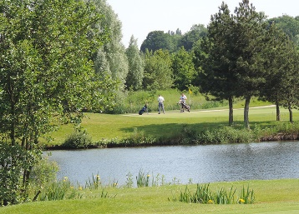**____________________________________________**

An opportunity to gather together colleagues and associates for an afternoon at Aston Wood Golf Club. This picturesque championship course, designed by Peter Alliss and Clive Clark, constructed to USPGA standard, provides 18 testing holes and a challenging course for both the casual and competitive golfer.

**Wednesday 9th July 2025**

***Golfers Order of the day***

12pm Lunch – Soup and Sandwiches

1pm Tee off

6pm Dinner & Prizes

***Course Fees***

Golfers - Two Players £160 + VAT

This event is also open to non-members – to book please complete the booking form below and include a PO number for invoice. We regret that tickets are non-refundable. Return to  [office@cecamidlands.co.uk](mailto:%20office@cecamidlands.co.uk)

|  |  |  |  |
| --- | --- | --- | --- |
| Player 1 name: |  | Player 2 name: |  |
| Contact email: |  | Contact email: |  |
| Company name: |  | Company name: |  |
| Handicap: |  | Handicap: |  |
| Staying for dinner? Yes/No |  | Staying for dinner? Yes/No |  |
|  | | | |
| **Payment details:** Company name: |  | PO Number: |  |
| Company Accounts Dept Contact Name: |  | Email/Telephone: |  |
| Company address: |  | | |
| Equipment Required: |  | | |

CECA Midlands Ltd, MR1 Business Hub, Wolverhampton Road, Codsall, WV8 1PX, 01746 762657, [office@cecamidlands.co.uk](mailto:office@cecamidlands.co.uk)