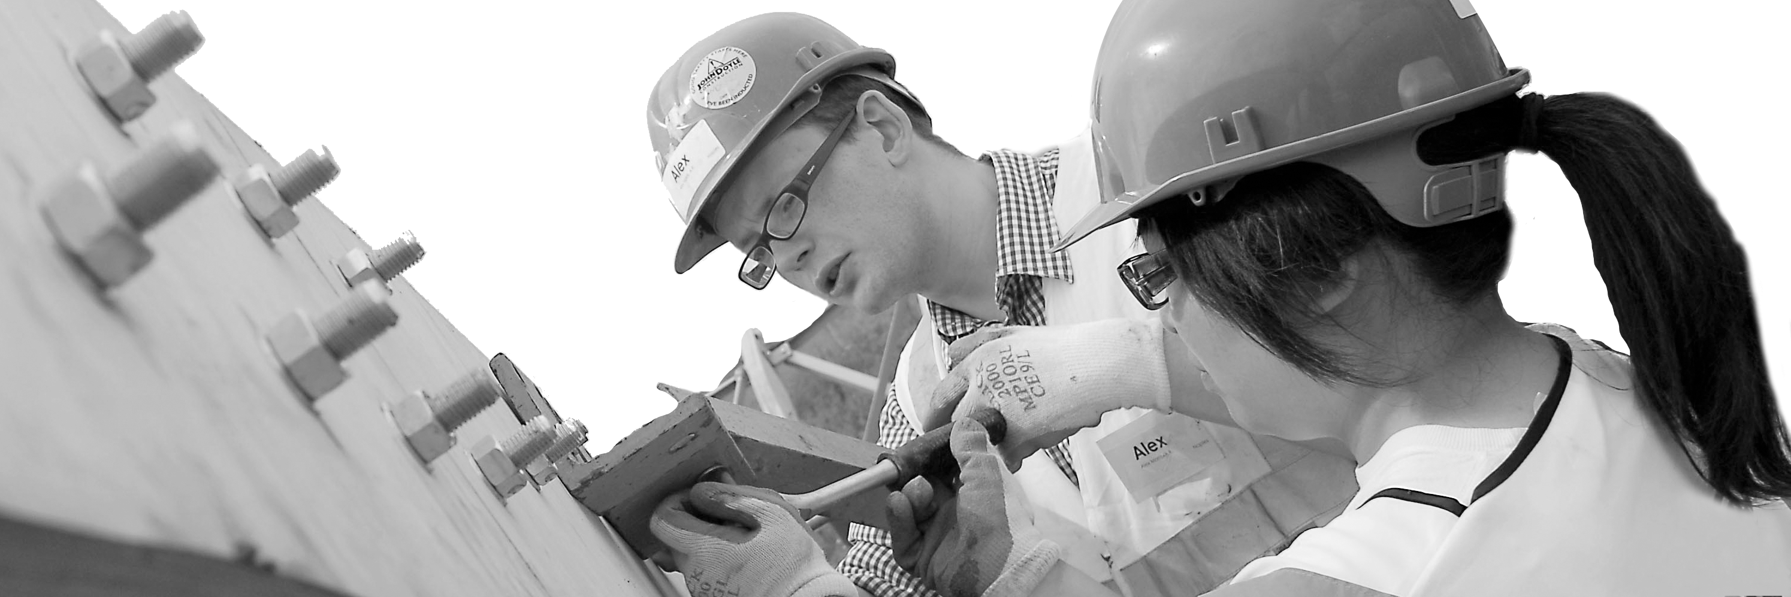
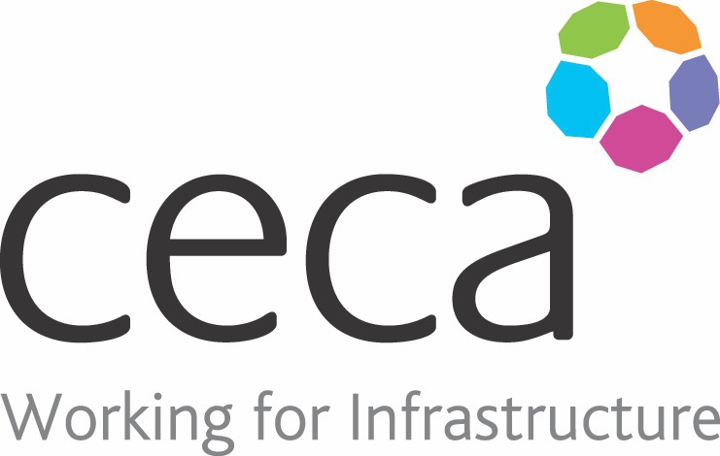
CECA Midlands E Learning

SLIPS, TRIPS AND FALLS
This Slips, Trips and Falls training course is designed to give you all the information you need to effectively recognise and control the risks from slip, trip and fall hazards in your workplace.
This particular fall prevention programme is for everyone –employers, safety representatives and employees – because after all, anyone can have a workplace accident.
Approved by RoSPA and taking around 30 minutes to complete, slips, trips and fall prevention training focuses attention on awareness, prevention and personal responsibility; as well as providing a clear step by step outline of how to identify and endeavour to minimise this kind of risk in a variety of work environments.
This course also looks at how to perform a comprehensive risk assessment for slips, trips and falls, and at the steps involved in putting appropriate measures in place to help prevent this kind of accident occurring.

Learning overview:
- Responsibilities
- Slips and trips

- Conclusion

Assessment:
This training programme concludes with a 20 question multiple choice test with printable certificate. In addition, brief in-course questionnaires guide the user through the sections of the training, and are designed to reinforce learning and ensure maximum user engagement throughout.

Cost: Registration fee £20 + VAT for full and associate CECA Midlands members.
Award: E learning certificate approved by ROSPA

Company name: |  | Company contact name:
Company email: |  | Contact tel:
Delegate name: |  | Job title:
Delegate email: |  | Delegate tel:
Accounts Name: |  | Accounts email:

Booking Form – please complete and return to admin@cecamidlands.co.uk one per delegate.
SLIPS TRIPS AND FALLS

